March/ April Ed Calendar
Account @Marriotthotels
Key: Caption needs to be written, Graphic or photo needs to be assigned
Date/time | Content | Image | Tw | LI | IG
3/8 | Today marks International Women’s Day and here at Marriott today, and every day we celebrate the amazing women who help us pursue excellence. #Internationalwomensday | [Graphic with photo of the women who make Marriott run] | x | x | x
3/9 | Dreaming of a mountain get away? Head to…  W Aspen, a Marriott International Hotel  Nestled at the bottom of a mountain from the access to slopes and trails, to stunning 360-degree mountain views this getaway has something for everyone.  @WASPENHOTEL  Tap the link in our bio for more information and other dream getaways. | 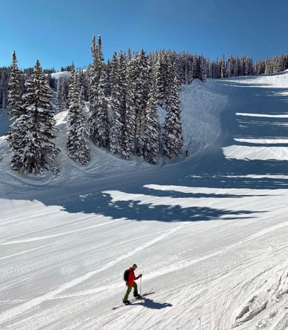Photo courtesy of @waspenhotel | X (only up to hotel) | x | x
3/10 | Do you consider vacations and trips to be the same thing? #Marriott |  | x
3/11 | Meet the Thaman sisters Allie, and Sarah. Each year the pair takes a trip together to spend time making memories just the two of them. “There is something special about these trips and the Marriott’s we stay at always are the cherry on top of the cake. No matter what we need, or what Sarah forgot the hotel always goes out of its way to make accommodations for us” said Allie when asked about these vacations. We look forward to hosting the sisters again soon. #Marriotmemories |  |  | x | x
3/11 | We are curious to know what is your favorite #marriottmemory? | N/A | x
3/12 | Weekend getaway location | [Photo of a bachelorette party @ a Marriott hotel in Nashville] | x | X | X
3/13 | Taking a selfcare Sunday to make it through daylight savings. What is your favorite form selfcare?  Photo courtesy of @summerriding |  | X | X | X
3/14 | Want to travel but feel stuck by your budget. Stay tuned for Bonvoy week where you will have the opportunity to learn the tips and tricks of the Marriott Bonvoy rewards program. #MarriottBonvoy |  | X | X | X
3/15 | It was an honor to host the annual conference for the Missouri Charter Public School Association last week at the Kansas City Downton Marriott. If you are interested in hosting an event with us, click on the link in our bio for more information. | 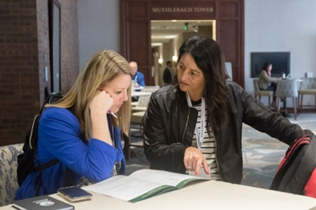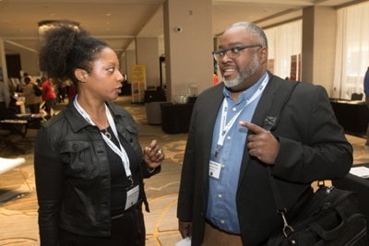 | X | X | X
3/16 | March sure is mad! We are proud to be an official sponsor of the NCAA. With athletes staying at one of the 30 brand hotels when traveling for March Madness. We are honored to provide a space for the future champions. #MarchMadness | [Insert photo of athletes at the hotel] | X | X | X
3/16 | Meet Robyn and her lovely family. We had the honor of hosting them last week at the Marriott Clearwater hotel and look forward to accommodating them with their next adventure. The family loves to travel and explore new places as they feel it brings them closer together. When asked why she continues to choose Marriott Robyn said that it is because of “the people, the staff at all Marriott International hotels that my family and I have stayed at have gone out of their way to make sure my family and I feel as though we are the most important people at the hotel. It truly is something special”. | 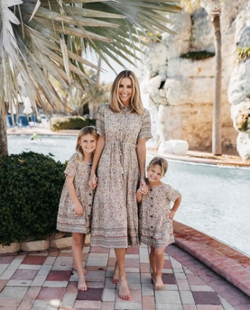 photo courtesy of @robyn |  | X | X
3/17 | We are feeling extra lucky today and wanted to share that feeling with all of you! Share your best Marriott St. Patrick’s Day pictures to enter the St. Patrick’s Day sweepstakes. The winner will receive a free stay at any participating Marriott International hotel. | [Pictures from major St. Patrick day celebrations] | X | X | X
3/18 | Special location | [Insert photo of said location] | X(only first few lines of post) | X
3/19 | Specific brand | [Insert brands top hotel] | X | X | X
3/20 | First day of spring | [Photo of the gardens throughout Marriott hotels] | X | X | X
3/21 | Kick off Marriott Bonvoy week | [Marriott Bonvoy graphic that explains what the program is and how to get involved] | X | X | X
3/22 | Marriott Bonvoy week Taylor’s story (grand adventure paid for with points) | [Picture relating to the adventure in the story] |  | X | X
3/23 | Marriott Bonvoy week (introduce Marriott Moments) | [Marriott Bonvoy graphic that explains what these moments are) | X | X | X
3/24 | Marriott Bonvoy week John’s story (Marriott Moment of taking his son to the Super Bowl paid with by Bonvoy points]) | [Picture of John and his son at the Super Bowl] |  | X | X
3/24 | What is your favorite aspect of the #MarriottBonvoy rewards program? | N/A | x
3/25 | Marriott Bonvoy week |  | X | X | X
3/26 | Marriott Bonvoy week |  | X | X | X
3/27 | Marriott Bonvoy week |  | X | X | X
3/28 | Dreaming of rooftops pools on the way to the office this morning.  Photo courtesy of @theadventurebabe |  | X | X | X
3/29 | Special location (post about a gem hotel)  Moxy hotels Patras, Greece | 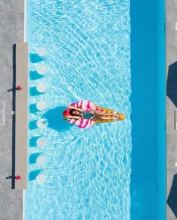 |  | X | X
3/30 | Highlight a specific brand | [Insert brands top hotel] |  | X | X
3/31 | March is always one of our favorite months of the year here at Marriott. Swipe through to see some of our favorite moments from the last month. #MarriottMarch | [Insert top pictures that show the Marriott mission that were taken in March] | X | X | X
4/1 | April showers post | [Picture of rain falling on one of the Marriott roof top lounges] | X | X | X
4/2 | Post for Ramadan | [Graphic honoring the holiday] | X | X | X
4/3 | Travel for work, stay for the happy hour! | 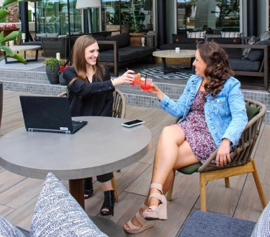 photo courtesy of @wscottsdale | X | X | X
4/4 | Special location (gem hotel) Dubai |  |  | X | X
4/5 | Dream travel location (start promoting summer travel use #dreammarriott for all the content related to this) |  |  | X | X
4/5 | If you could travel anywhere in the world, where would it be? #Dreammarriott | N/A | X
4/6 | Marriott memory | [Photo related to the Marriott memory] |  | X | X

